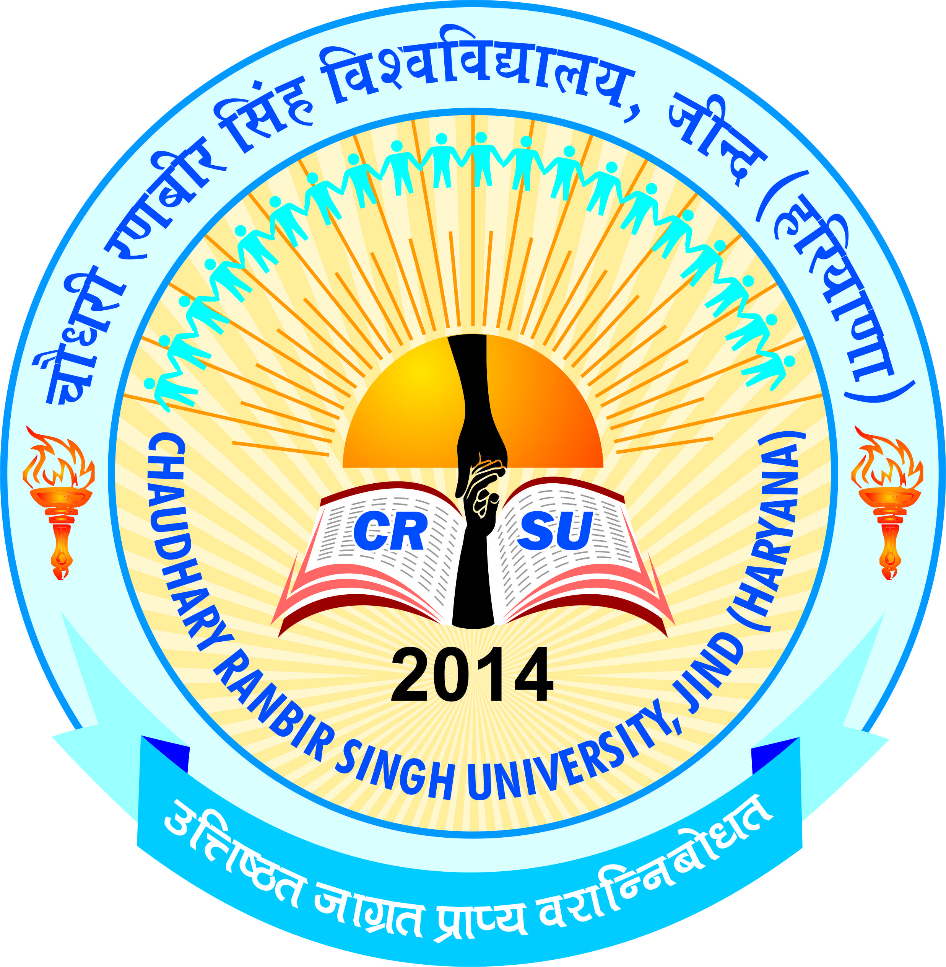 | pkS/kjh j.kchj flag fo'ofo|ky;]thUn  Chaudhary Ranbir Singh University, Jind  (Established by the State Legislature Act 28 of 2014) | 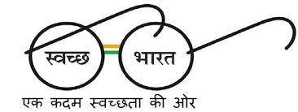

NOTICE

ADMISSION SCHEDULE OF PHYSICAL COUNSELING FOR VACANT/ADDITIONAL/ SUPERNUMERARY SEATS FOR ADMISSION TO VARIOUS COURSES 2017-18
It is notified that the physical counseling for admissions to following courses being run in the University will be carried out by the respective Department as per schedule given below:
Name of Course | Date & Time of reporting of candidates for physical counseling | Date & time for display of merit list | Fee/dues depositing up to | Venue
M.Com  M.A. (Economics)  MBA  MA (Mass Com.)  MA (English)  MA (History)  M.Sc. (Geography)  M.P.Ed.  MA (Psychology)  M.Sc (Mathematics) | 27.07.2017  09.00 a.m. to 12.00 noon | 27.07.2017  at 1.30 p.m. | 27.07.2017 upto 4.00 p.m | In the concerned Department at CRSU, Jind
Remaining Seats for the above courses, if any | 28.07.2017  09.00 a.m. to 12.00 noon | 28.07.2017  at 1.30 p.m. | 28.07.2017  upto 4.00 p.m | -do-
Note:
- The candidates who appeared in Common Entrance Exam.(CEE) will only be eligible to seek admission. The candidates are required to get their documents verified and deposit the full fee.
- In case, at the time of Physical counseling, no eligible candidate of the reserved category (other than SC category) is available, these seats will be filled up on open merit basis.
For more details visit www.crsu.ac.in
Sd/-
Registrar

